**Exercise 1: Setting Up Junit**

**Junit Dependency Added to Java Project**

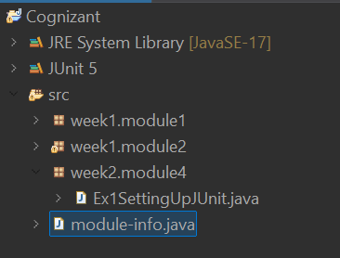

**New Test Class**

package week2.module4;

import org.junit.Test;

import static org.junit.Assert.assertEquals;

public class Ex1SettingUpJUnit {

@Test

public void testMultiply() {

assertEquals(20, multiply(4, 5));

}

private int multiply(int a, int b) {

return a * b;

}

}

**Output:**

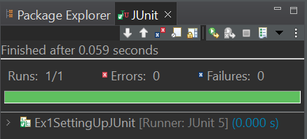

**Exercise 2: Writing Basic JUnit Tests**

**Code:**

package week2.module4;

import org.junit.Test;

import static org.junit.Assert.*assertEquals*;

class Calculator {

public int add(int a,int b) {

return a+b;

}

public int subtract(int a,int b) {

return a-b;

}

public int multiply(int a,int b) {

return a*b;

}

public int divide(int a,int b) {

if(b==0) {

throw new IllegalArgumentException("Cannot divide by 0");

}

return a/b;

}

}

public class Ex2Calculator{

Calculator c=new Calculator();

*@Test*

public void testAdd() {

*assertEquals*(5,c.add(2, 3));

}

*@Test*

public void testSubtract() {

*assertEquals*(-1,c.subtract(2, 3));

}

*@Test*

public void testMultiply() {

*assertEquals*(6,c.multiply(2, 3));

}

*@Test*

public void testDivide() {

*assertEquals*(2,c.divide(4, 2));

}

}

**Output:**

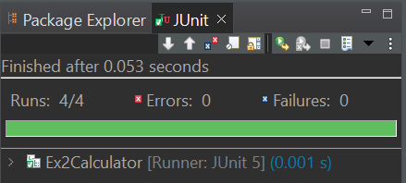

**Exercise 3: Assertions in Junit**

**Code:**

package week2.module4;

import org.junit.Test;

import static org.junit.Assert.*;

public class Ex3AssertionsTest {

@Test

public void testAssertion1() {

// Assert Equals

assertEquals(5, 2 + 3);

}

@Test

public void testAssertion2() {

// Assert True

assertTrue(5 > 3);

}

@Test

public void testAssertion3() {

// Assert False

assertFalse(5 < 3);

}

@Test

public void testAssertion4() {

// Assert Null

assertNull(null);

}

@Test

public void testAssertion5() {

// Assert Not Null

assertNotNull(new Object());

}

}

**Output:**

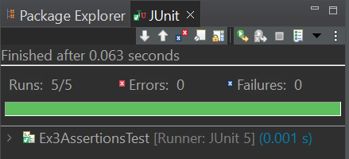

**Exercise 4: Arrange-Act-Assert (AAA) Pattern, Test Fixtures, Setup and Teardown Methods in JUnit**

**Code:**

package week2.module4;

import org.junit.*;

import static org.junit.Assert.*;

public class Ex4AAAPatternSetupTeardown {

*@Before*

public void setUp() {

System.***out***.println("This method setUp executes before each test cases");

}

*@Test*

public void testAdd() {

// Arrange

int a=5,b=3;

int expected=8;

// Act

int result=add(a,b);

// Assert

*assertEquals*(expected,result);

System.***out***.println("Test Case-1");

}

*@Test*

public void testMultiply() {

// Arrange

int a=5,b=3;

int expected=15;

// Act

int result=multiply(a,b);

// Assert

*assertEquals*(expected,result);

System.***out***.println("Test Case-2");

}

*@After*

public void tearDown() {

System.***out***.println("This method tearDown executes after each test cases");

}

public int add(int a,int b) {

return a+b;

}

public int multiply(int a,int b) {

return a*b;

}

}

**Output:**

